/*
Neeti Kurulkar
SE Div: A Batch: S2
Roll No. : 21038
DSAL Practical Assignment 11

Assume we have two input and two output tapes to perform the sorting. The internal
Memory can hold and sort m records at a time. Write a program in java for external
sorting. Find out time complexity.
*/

import java.io.*;
import java.util.ArrayList;
import java.util.Collections;

public class LA11 {
public static void main(String[] args) {
String inputFileName = "numbers.txt"; // Replace with the actual input file name
String outputFileName = "sorted_numbers.txt"; // Replace with the desired output file name

ArrayList<Integer> numbers = readNumbersFromFile(inputFileName);
if (numbers != null) {
Collections.sort(numbers);
if (writeNumbersToFile(outputFileName, numbers)) {
System.out.println("Sorted numbers written to " + outputFileName);
} else {
System.out.println("Failed to write sorted numbers to file.");
}
} else {
System.out.println("Failed to read numbers from file.");
}
}

private static ArrayList<Integer> readNumbersFromFile(String fileName) {
ArrayList<Integer> numbers = new ArrayList<>();

try (BufferedReader br = new BufferedReader(new FileReader(fileName))) {
String line;
while ((line = br.readLine()) != null) {
try {
int number = Integer.parseInt(line);
numbers.add(number);
} catch (NumberFormatException e) {
System.err.println("Invalid number found: " + line);
}
}
} catch (IOException e) {
System.err.println("Error reading file: " + e.getMessage());
return null;
}

return numbers;
}

private static boolean writeNumbersToFile(String fileName, ArrayList<Integer> numbers) {
try (BufferedWriter bw = new BufferedWriter(new FileWriter(fileName))) {
for (int number : numbers) {
bw.write(Integer.toString(number));
bw.newLine();
}
} catch (IOException e) {
System.err.println("Error writing to file: " + e.getMessage());
return false;
}

return true;
}
}

Output:

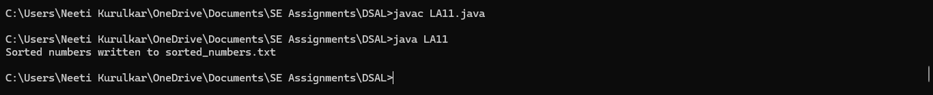

Numbers file:

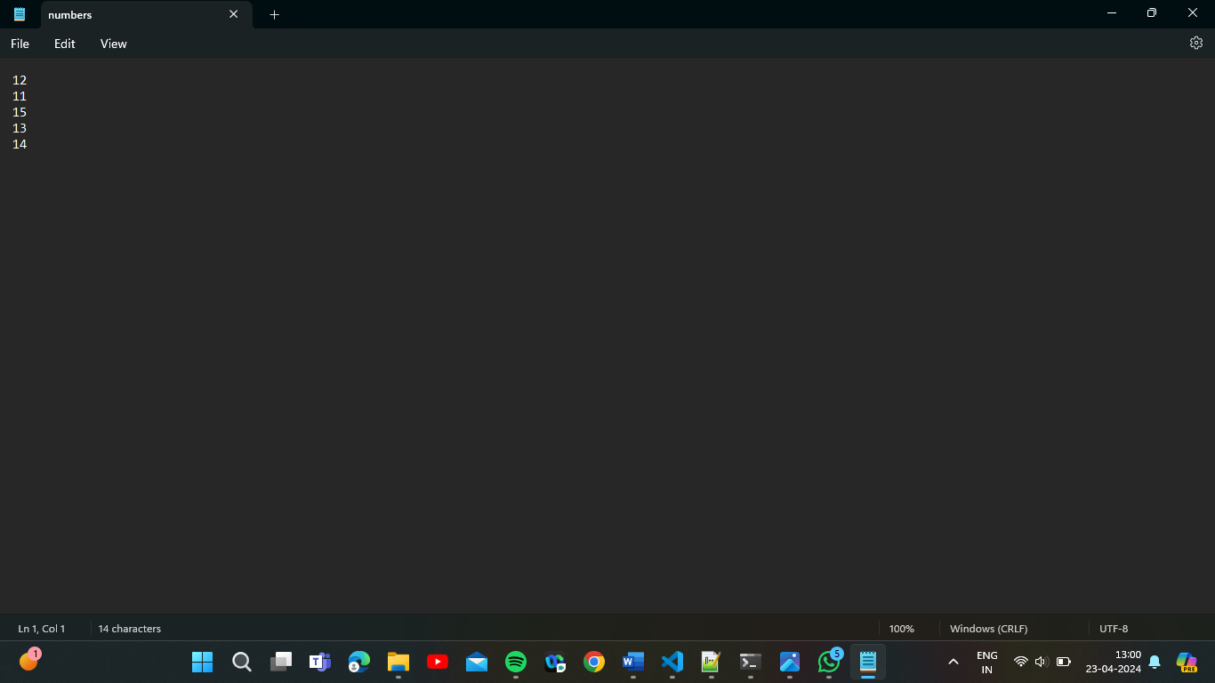

Sorted_numbers file:

